

# AUGUST- 2023

**Programme : B.E / B. Tech**

**Course Code : CSA1178**

**Course Name** : **Object Oriented Analysis and Design**

**Date : 08-08-2023**

PRATICAL SESSION PROGRAMS OF OOAD

**EXP 1: PASSPORT MANAGEMENT SYSTEM**

**AIM:**  To draw UML diagram for Passport Managment System using Umbrello.

**USE CASE:**

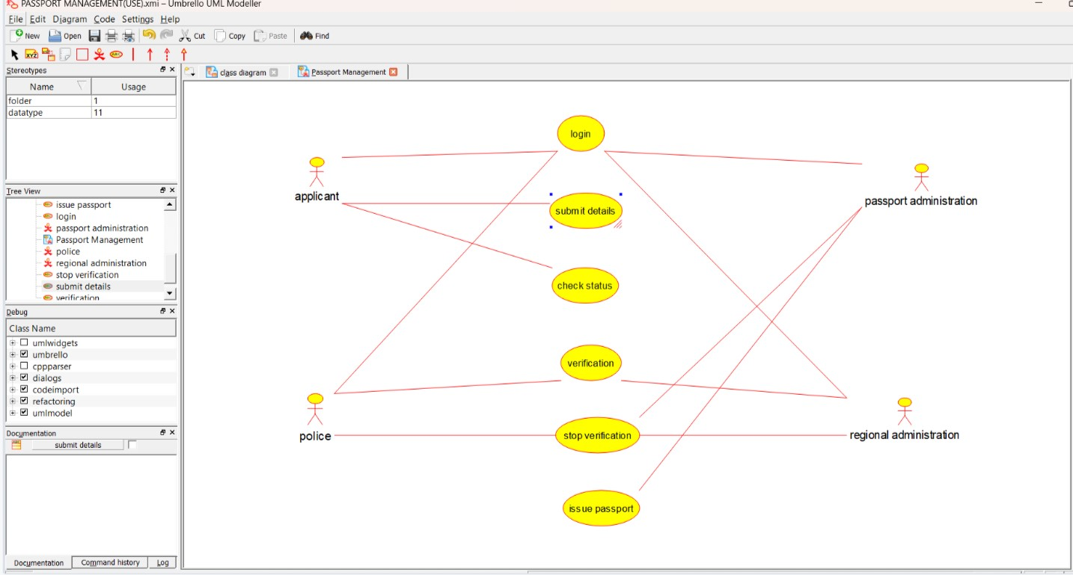

**COLLABRATION :**

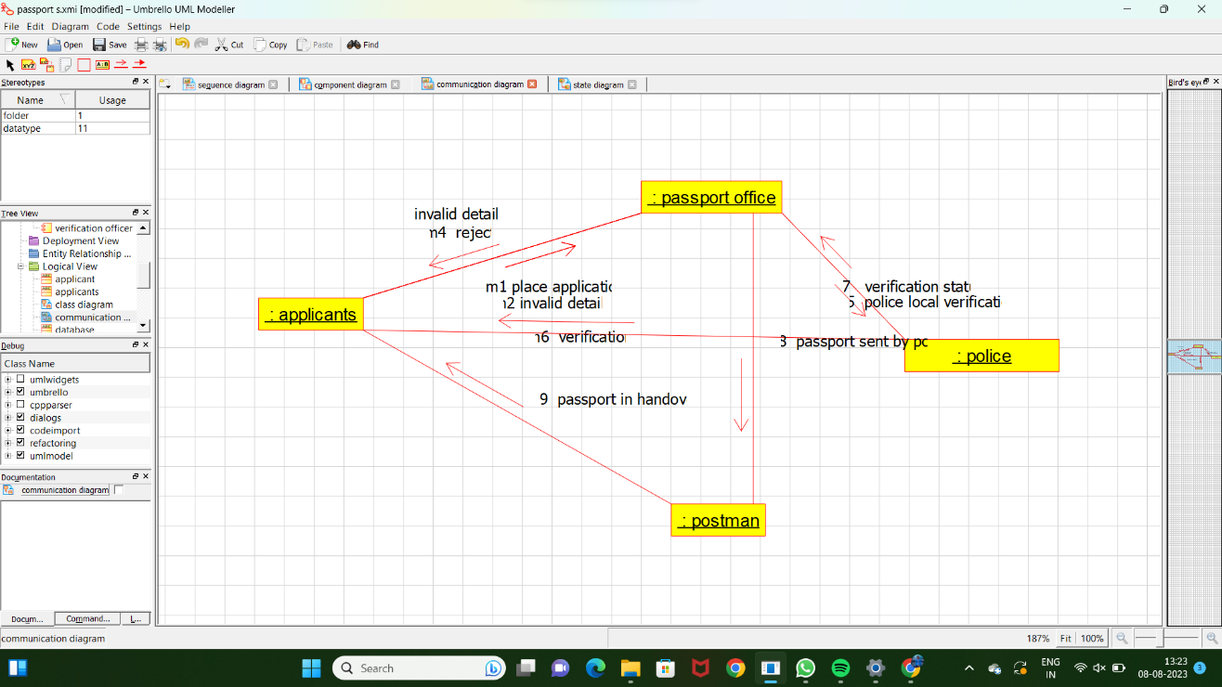

**STATE CHART DIAGRAM:**

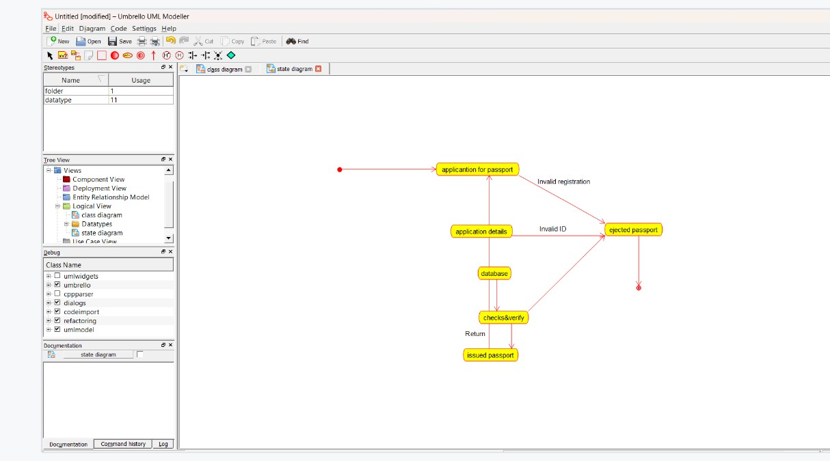

**RESULT : PROGRAM WAS SUCESSFULLY EXECUTED USING UMBRELLO.**

**EXP 2: BOOK BANK SYSTEM**

**AIM:** To draw Uml diagram for book bank system using umbrello.

**USE CASE:**

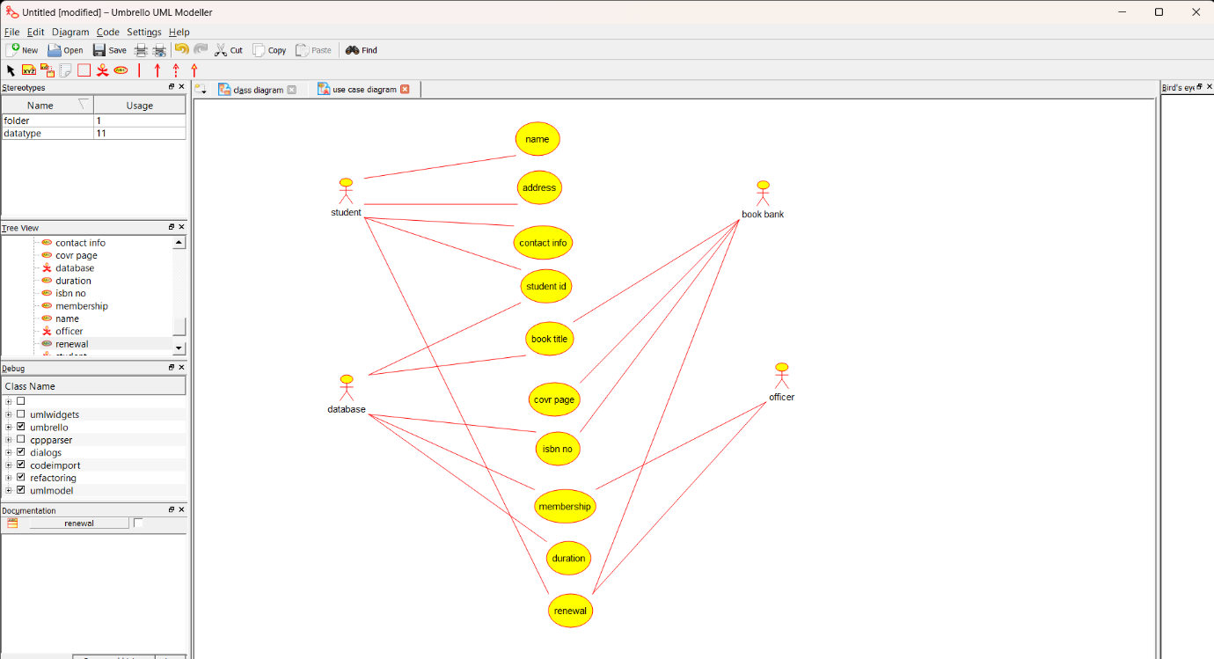

**ACTIVITY :**

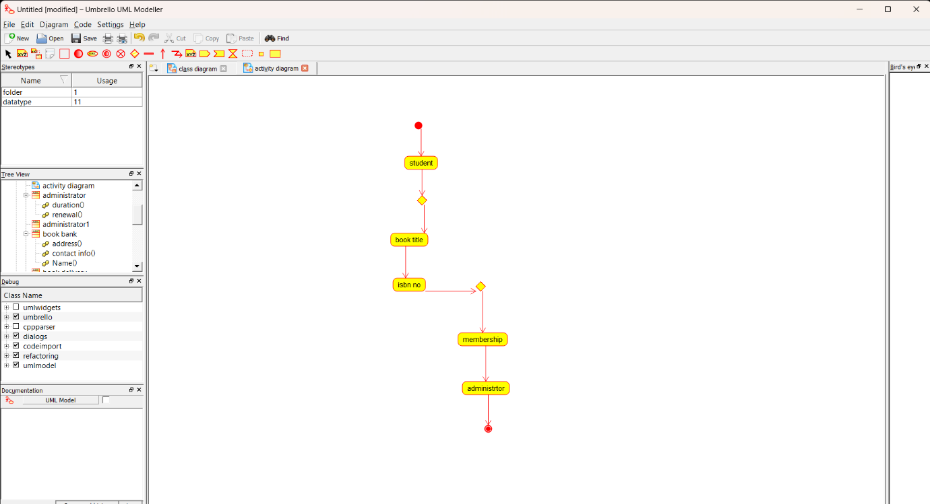

**SEQUENCE DIAGRAM :**

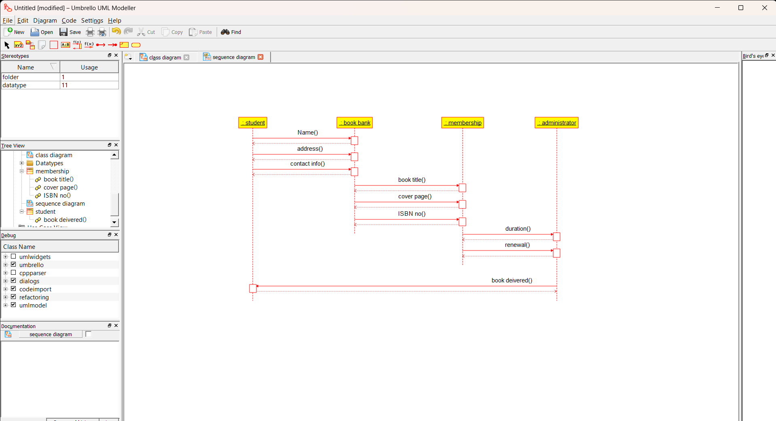

**RESULT : PROGRAM WAS SUCESSFULLY EXECUTED USING UMBRELLO.**

**Exp 3: EXAM REGISTRATION PORTAL**

**AIM :** To draw UML diagrams for Exam Registration Portal using Umbrello**.**

**USE CASE :**

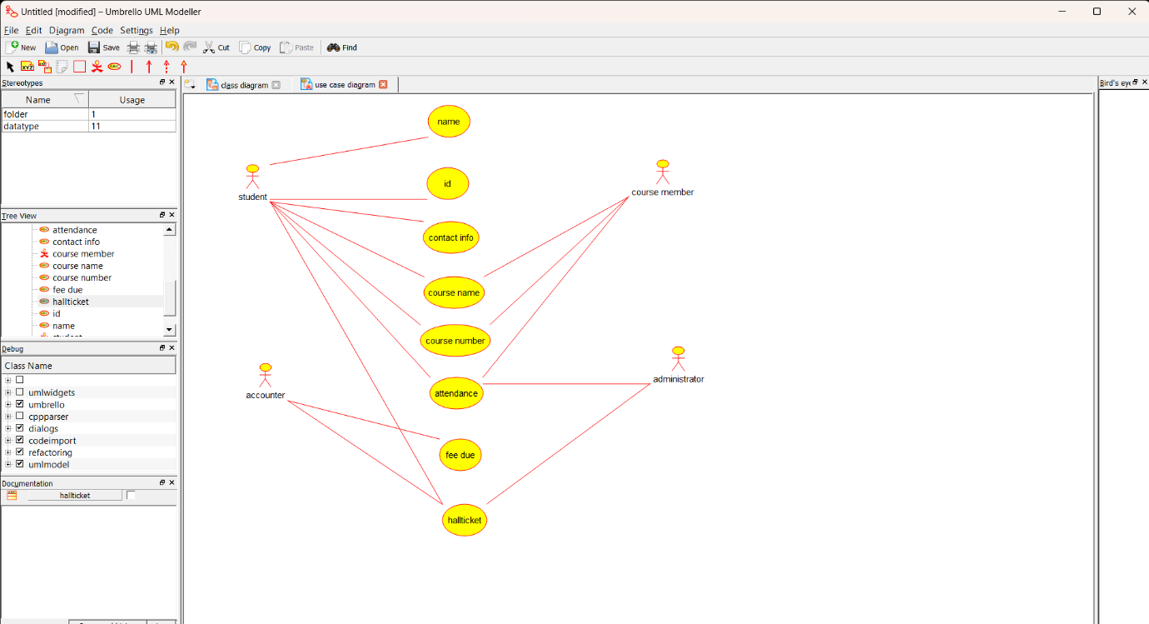

**ACTIVITY:**

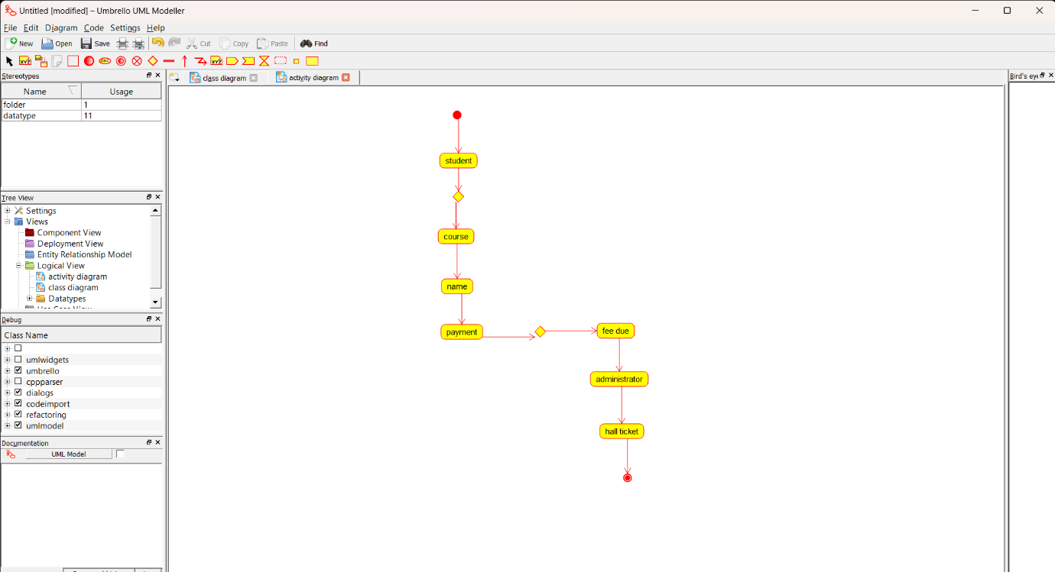

**COLLABRATION:**

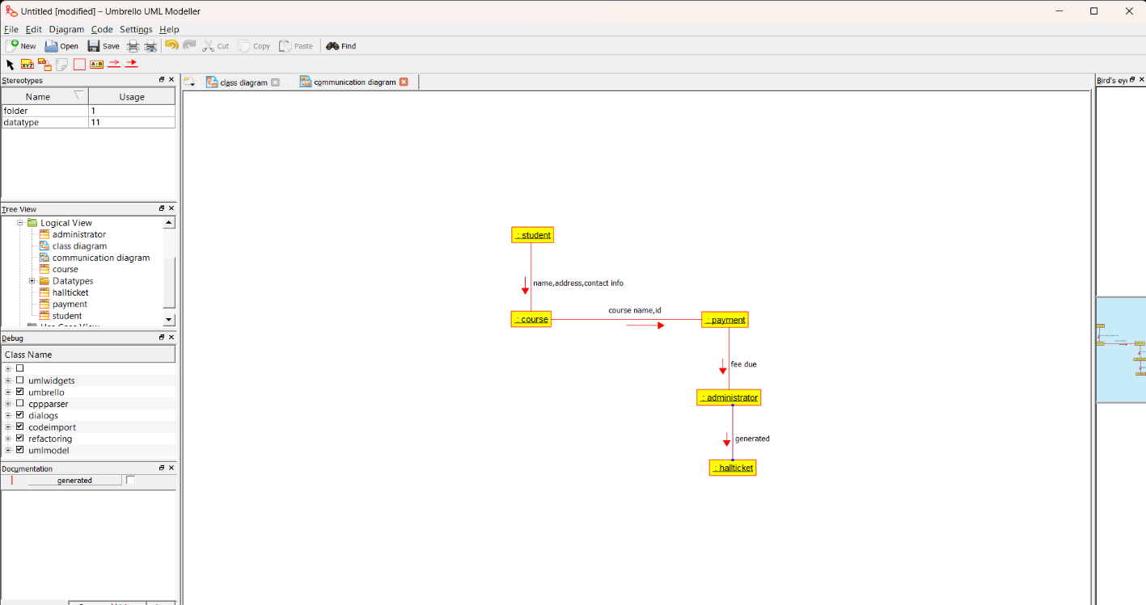

**RESULT : PROGRAM WAS SUCESSFULLY EXECUTED USING UMBRELLO.**

**EXP 4: STOCK MARKETING SYSTEM**

**AIM**: To draw UML diagram for Stock Marketing System using Umbrello**.**

**COMMUNICATION :**

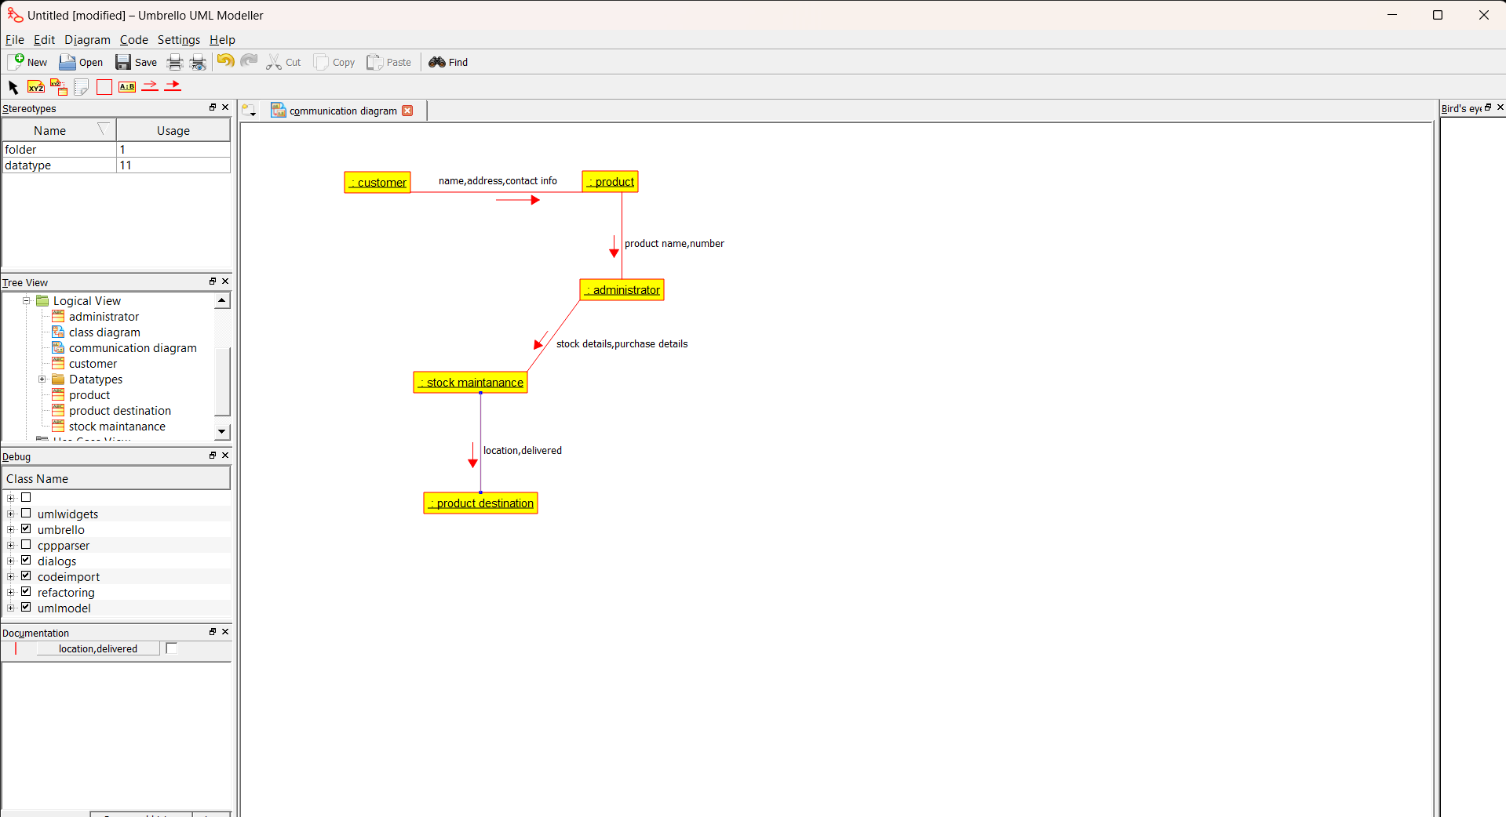

**SEQUENCE :**

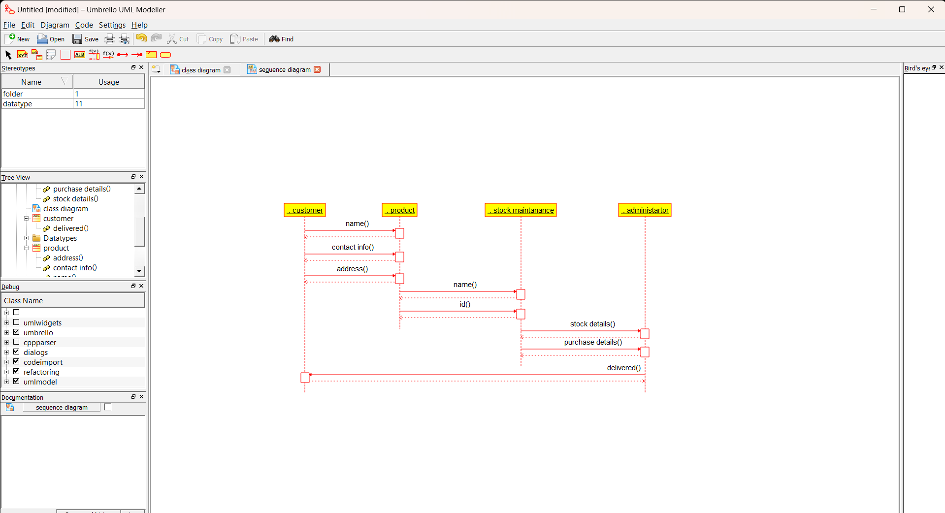

**PACKAGE :**

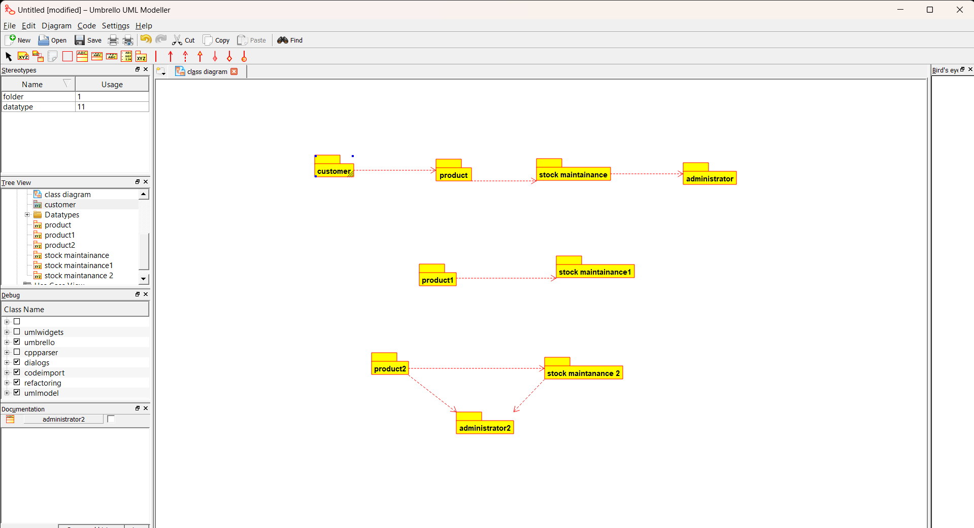

**RESULT : PROGRAM WAS SUCESSFULLY EXECUTED USING UMBRELLO.**

**EXP 5: ONLINE COURSE REGISTRATION**

**AIM :** To draw UML diagrams for Online course registration using umbrello.

**SEQUENCE :**

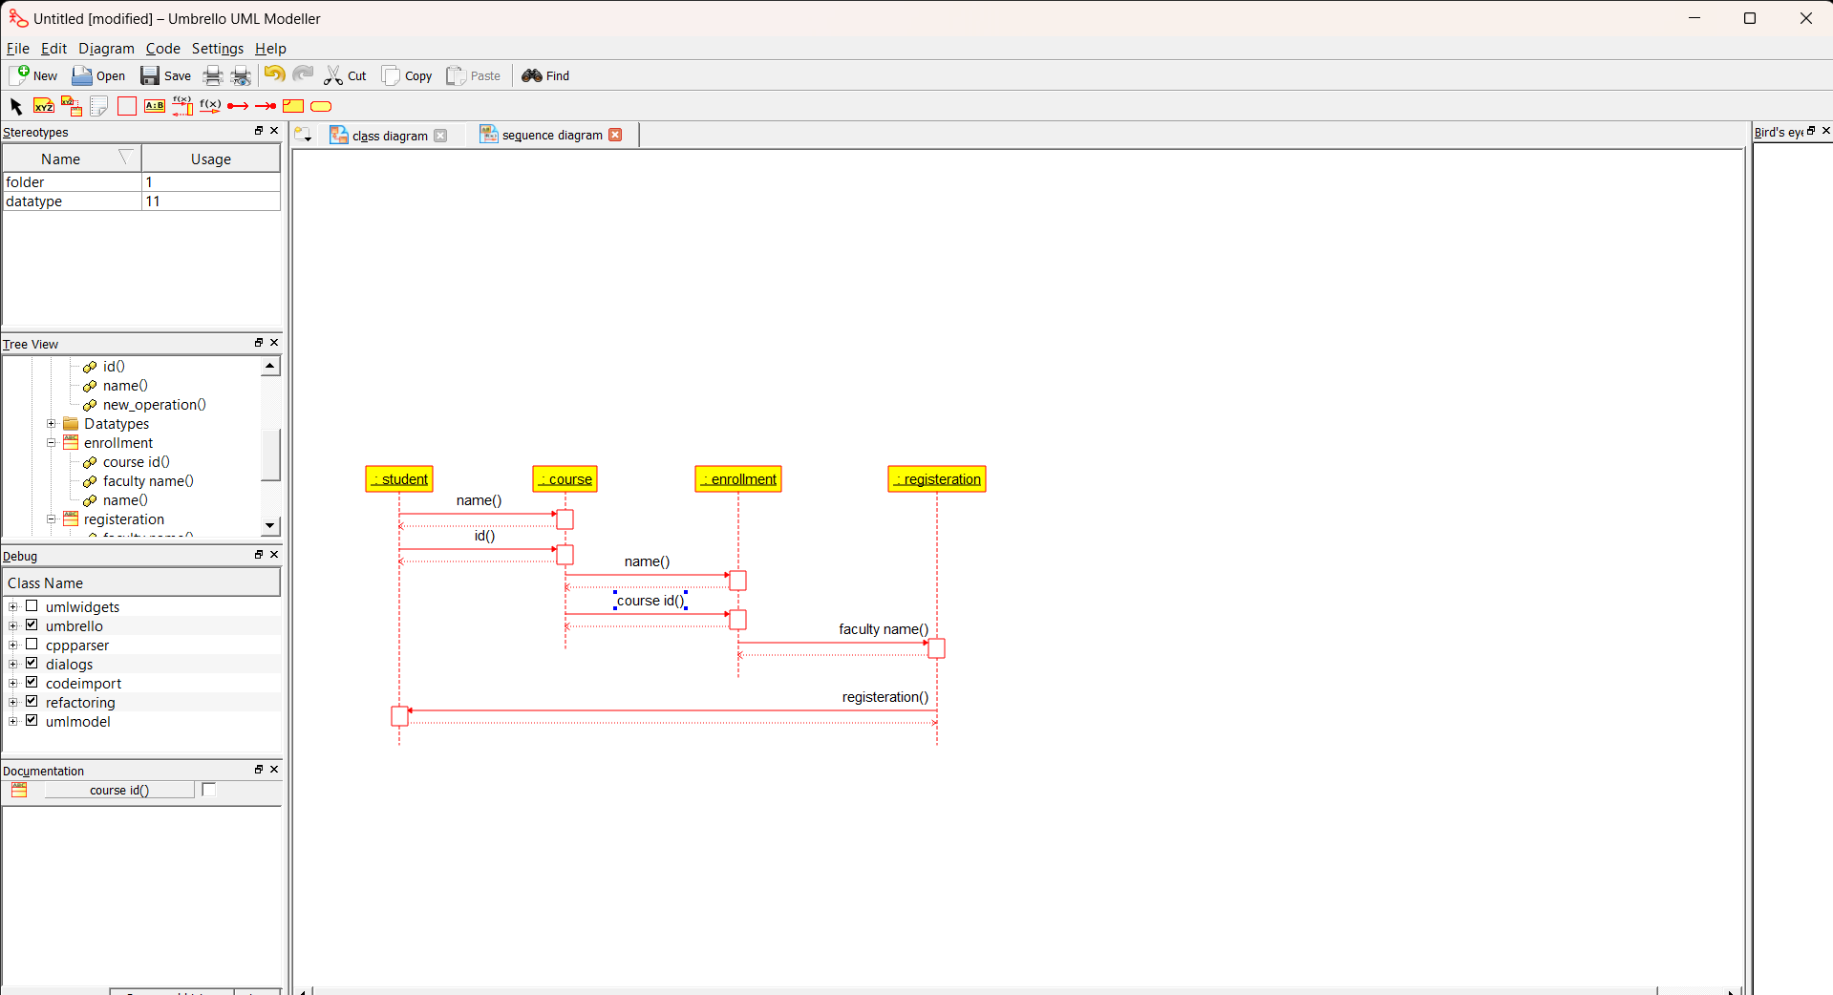

**STATE CHART :**

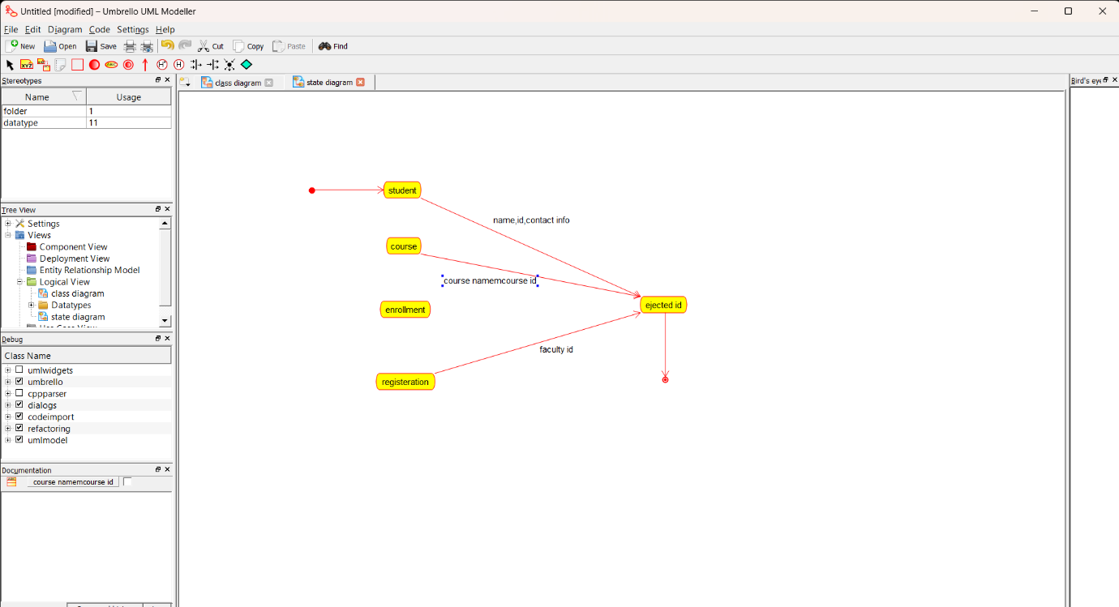

**ACTIVITY :**

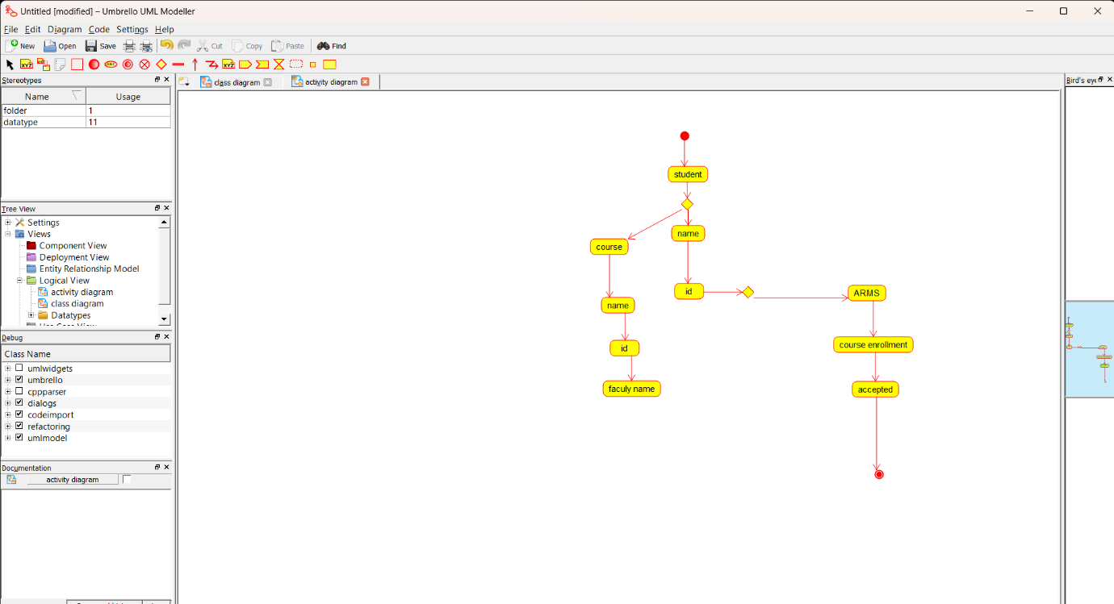

**RESULT : PROGRAM WAS SUCESSFULLY EXECUTED USING UMBRELLO.**

**EXP 6: E- TICKETING SYSTEM**

**AIM:** To draw uml diagram for e- ticketing system using umbrello.

**USE CASE:**

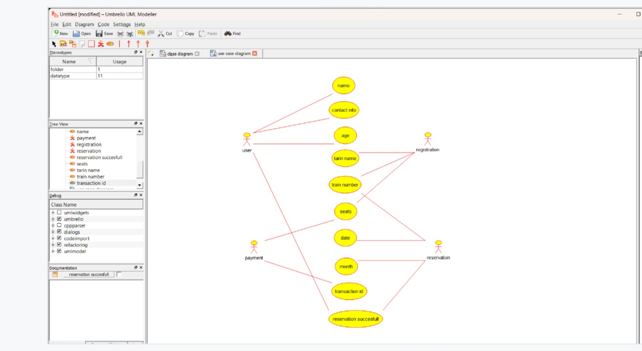

**ACTIVITY :**

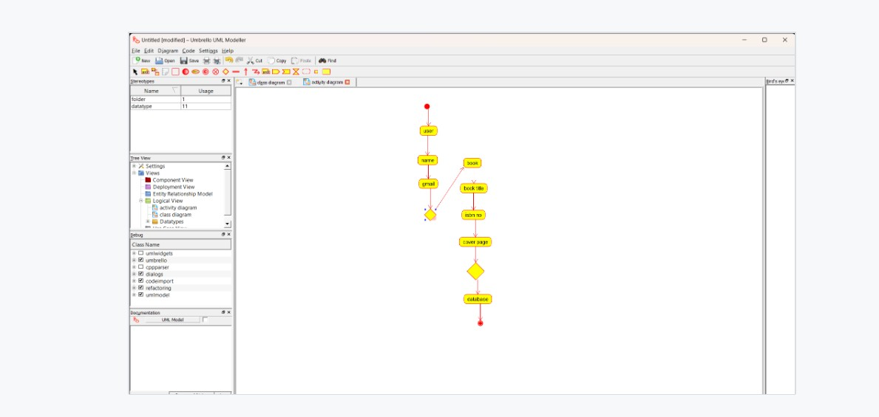**DEPLOYMENT:**

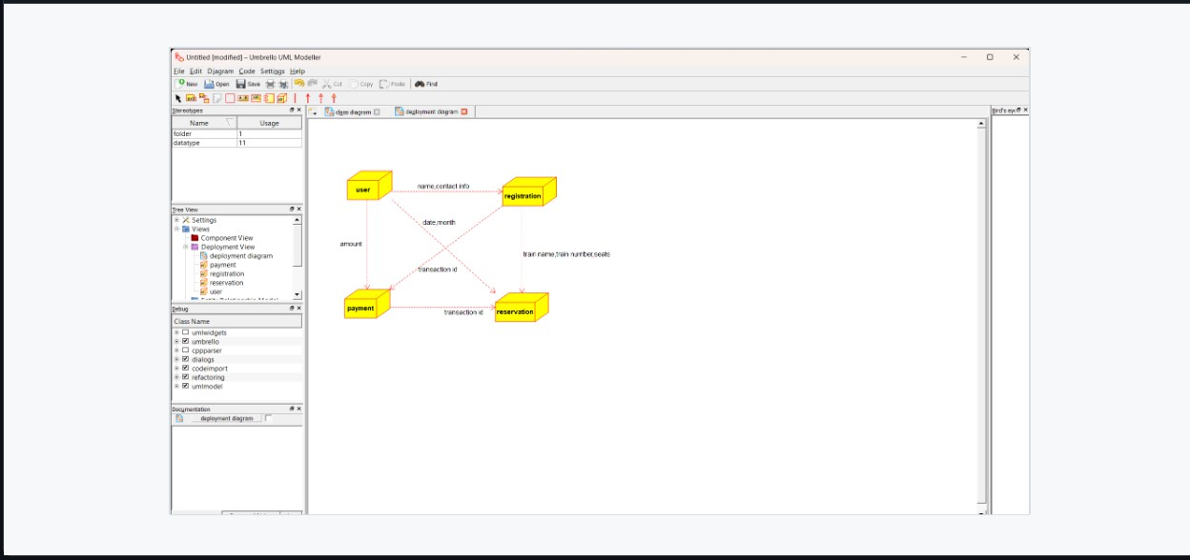

**RESULT : PROGRAM WAS SUCESSFULLY EXECUTED USING UMBRELLO.**

**EXP 7: CREDIT CARD PROCESSING SYSTEM**

**AIM:** To draw UML diagrams for credit card processing system using umbrello.

**DEPLOYMENT:**

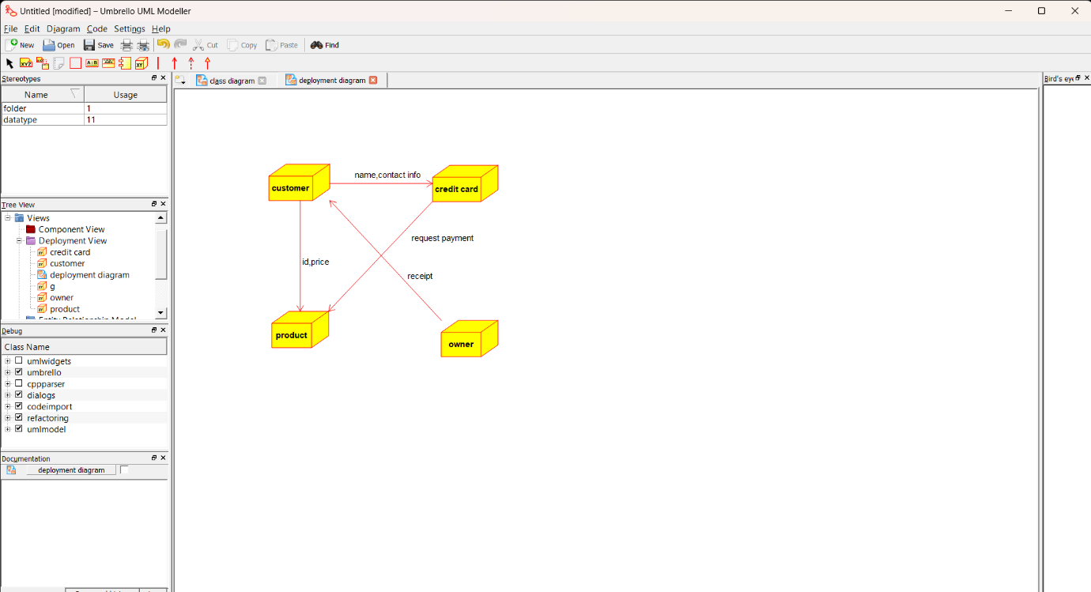

**STATE CHART :**

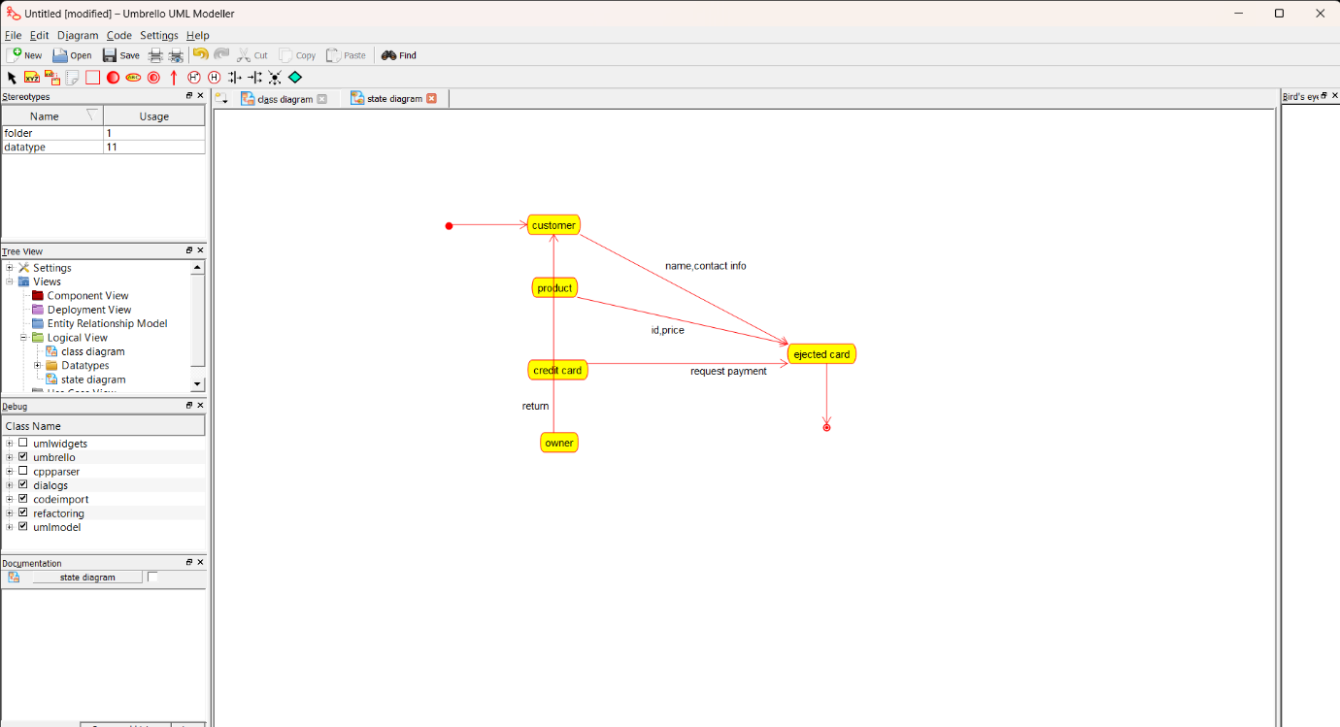

**COLLABRATION :**

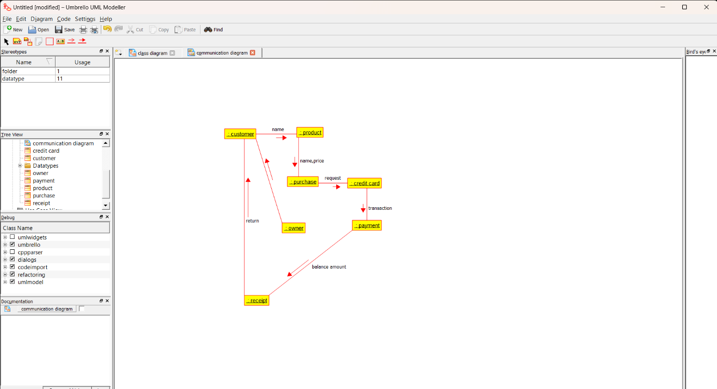

**RESULT : PROGRAM WAS SUCESSFULLY EXECUTED USING UMBRELLO.**

**EXP 8: SOFTWARE PERSONAL MANAGEMENT**

**AIM** : To draw uml diagram for software personal managment using umbrello.

**COLLABRATION :**

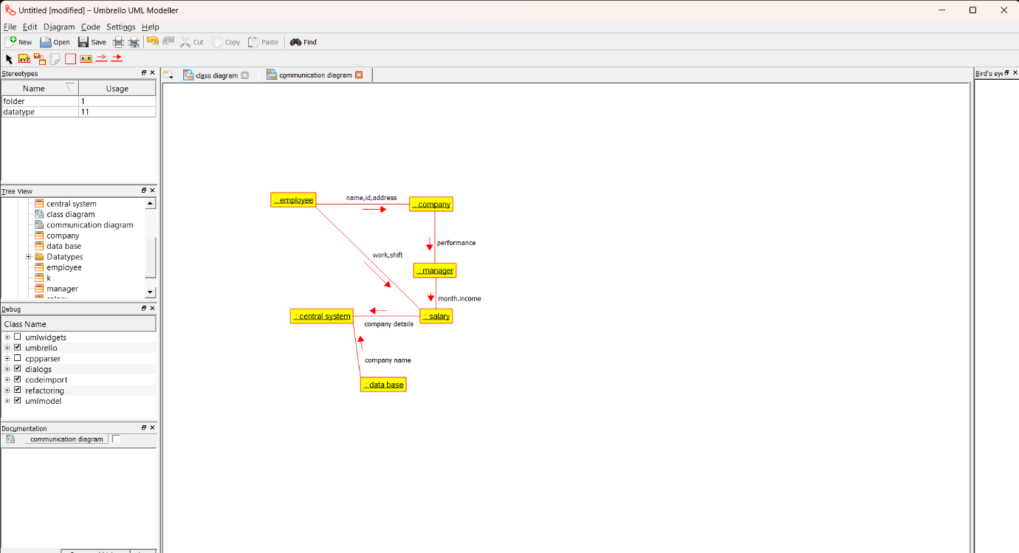

**PACKAGE :**

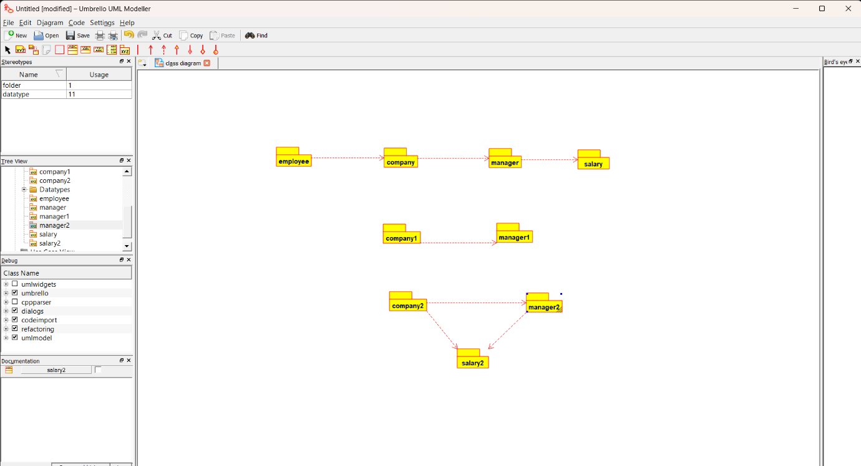

**USE CASE :**

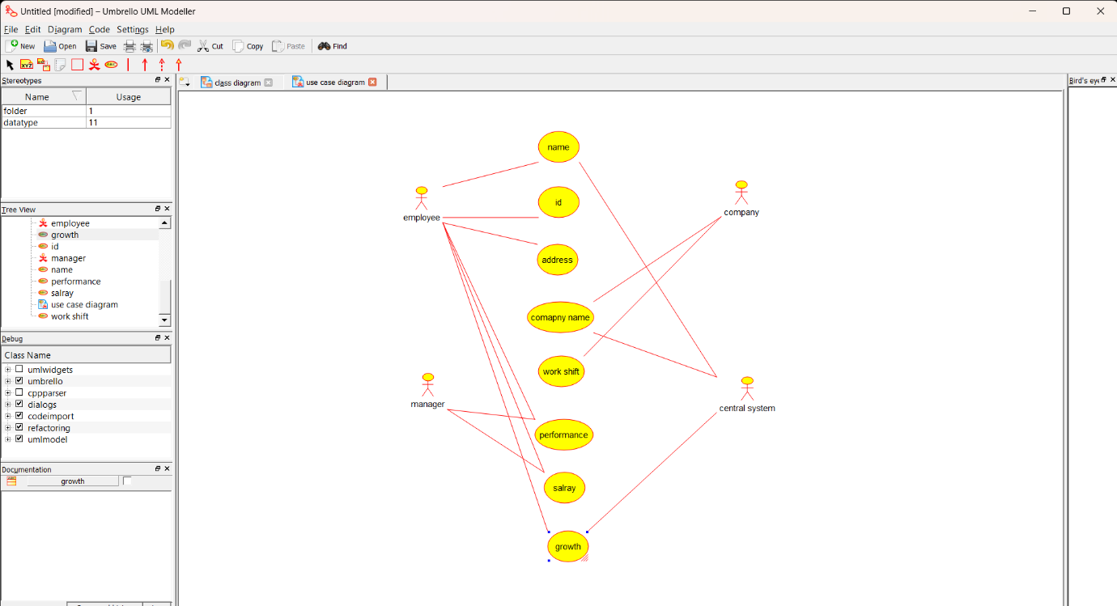

**RESULT : PROGRAM WAS SUCESSFULLY EXECUTED USING UMBRELLO.**

**EXP 9: E-BOOK MANAGEMENT**

**AIM:** To draw uml diagram for e- book management using umbrello**.**

**ACTIVITY :**

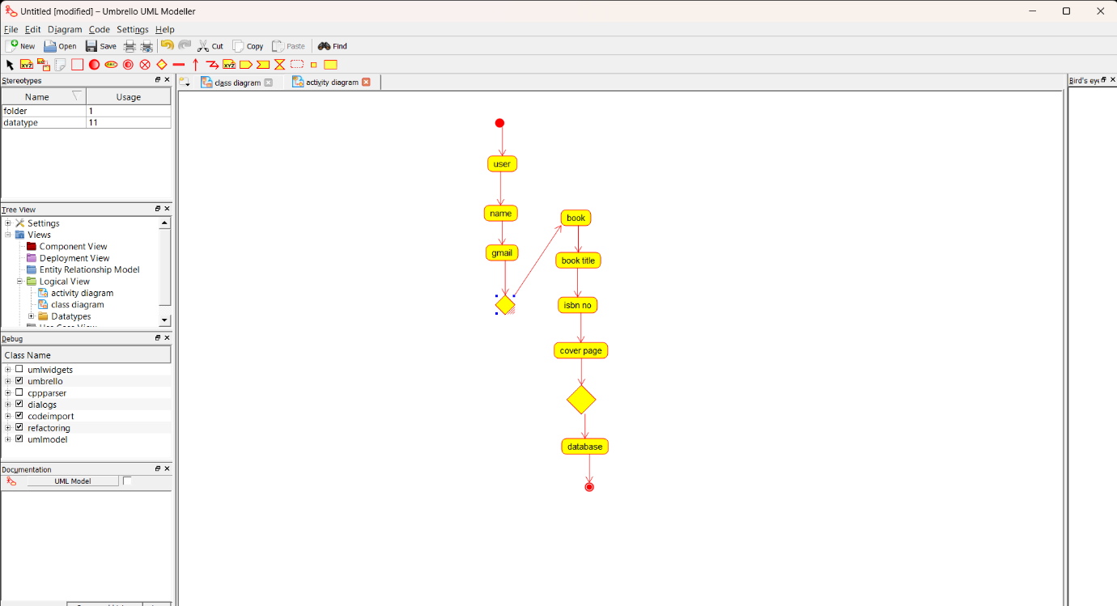

**COMPONENT :**

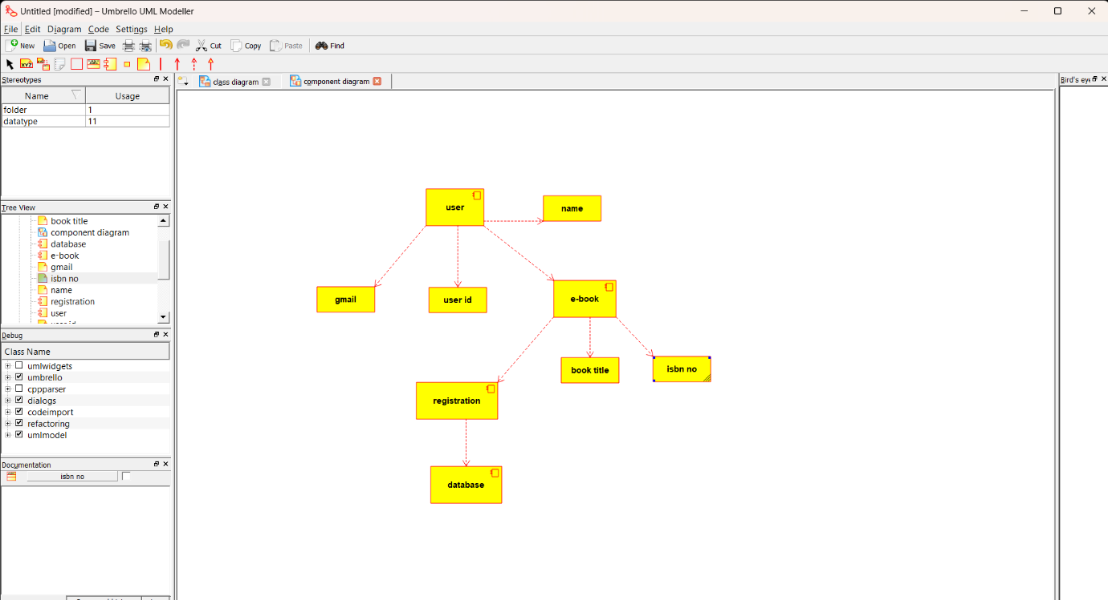

**PACKAGE :**

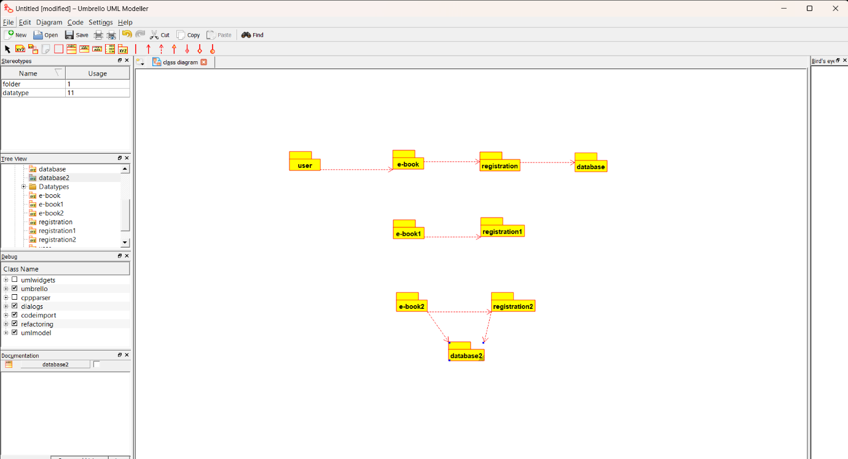

**RESULT : PROGRAM WAS SUCESSFULLY EXECUTED USING UMBRELLO.**

**EXP 10: RECRUITMENT SYSTEM**

**AIM : To draw uml diagrams for recruitment system using umbrello.**

**PACKAGE :**

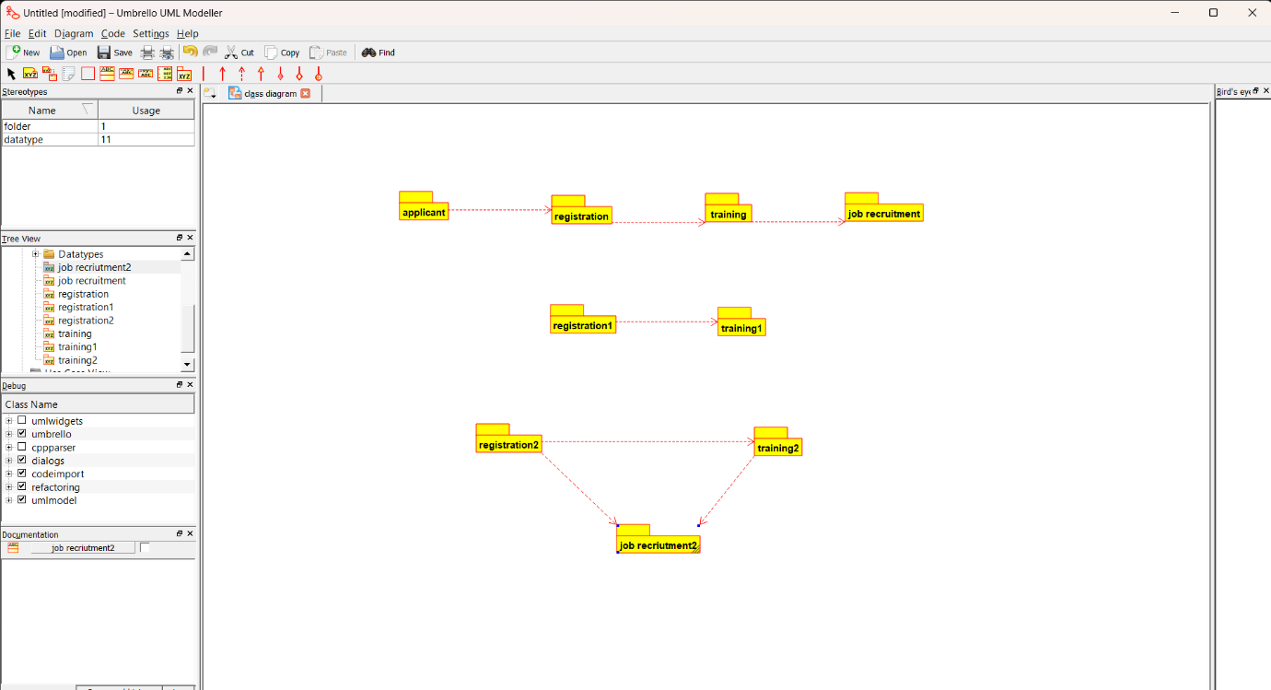

**DEPLOYMENT :**

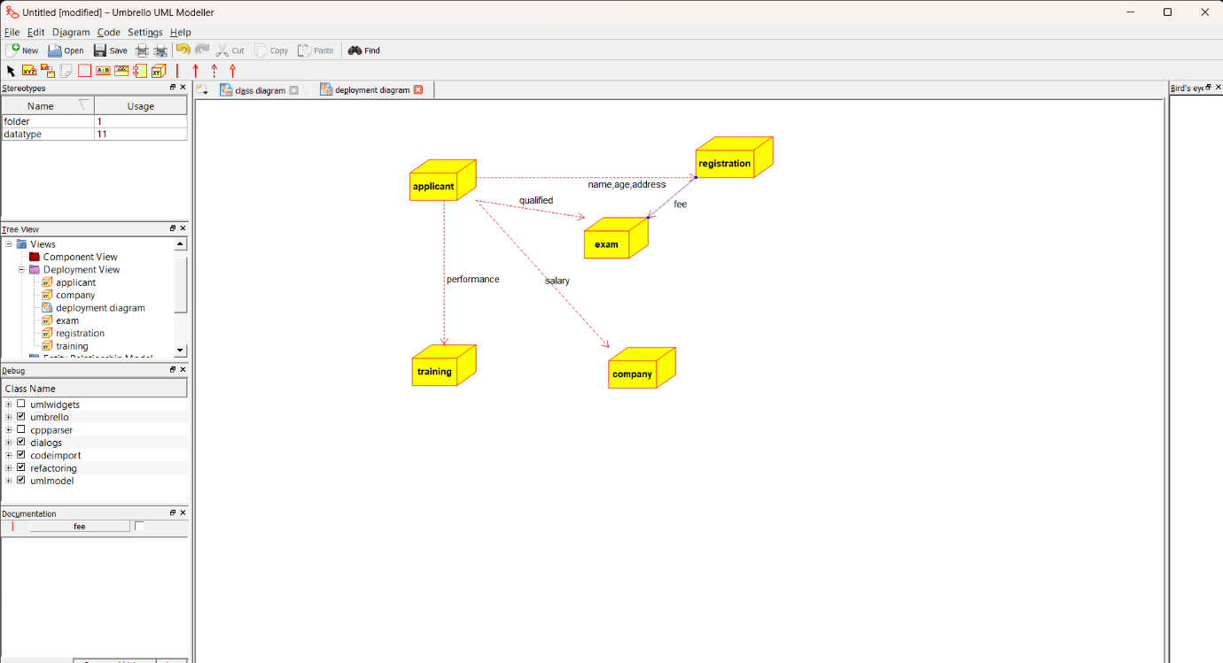

**COMPONENT :**

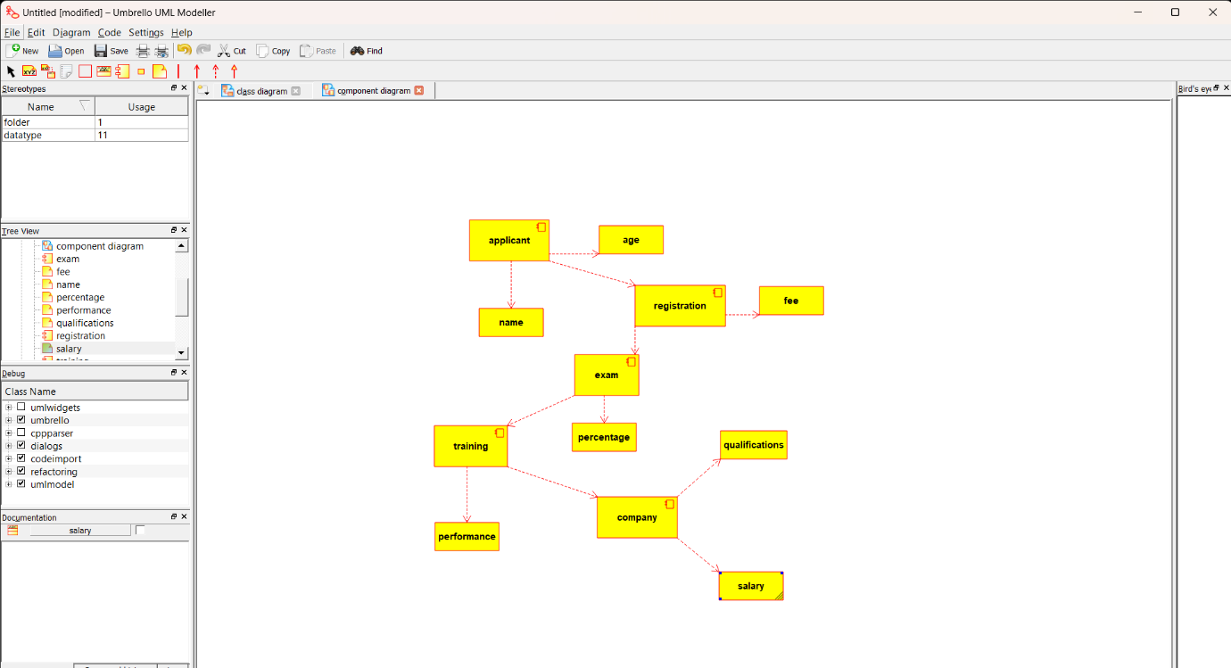

**RESULT : PROGRAM WAS SUCESSFULLY EXECUTED USING UMBRELLO.**